# **GOVERNMENT POLYTECHNIC COLLEGE MATTANNUR-670702**

**(Department of Technical Education, Kerala)**



**SEMINAR REPORT ON**

**DTH TECHNOLOGY**

**SUBMITTED BY**

**ABHINAND A**

**(Reg.No:19041624)**

**DEPARTMENT OF ELECTRONICS ENGINEERING**

**2021-22**

**GOVERNMENT POLYTECHNIC COLLEGE MATTANNUR-670702**

**(Department of Technical Education, Kerala)**



**CERTIFICATE**

*Certified that seminar work entitled* “***DTH TECHNOLOGY*** *“is a bonafide work carried out by* **“*ABHINAND A*”** *in partial fulfilment for the award of Diploma in Electronics Engineering from Government Polytechnic College Mattannur during the academic year* 2021-22.

### **Seminar Co-ordinator** **Head of Section**

**Internal Examiner External Examiner**

**DECLARATION**

I hereby declare that the report of *the* ***DTH TECHNOLOGY*** work entitled which is being submitted to the Govt. Polytechnic College Mattannur, in partial fulfilment of the requirement for the award **of *Diploma in Electronics Engineering*** *i*s a confide report of the work carried out by me. The material in this report has not been submitted to any institute for the award of any degree.

Place:Mattanur **ABHINAND A**

Date:

**ACKNOWLEDGMENT**

I would like to take this opportunity to extend my sincere thanks to people who helped me to make this seminar possible. This seminar will be incomplete without mentioning all the people who helped me to make itreal.

Firstly, I would like to thank GOD, almighty, our supreme guide, for bestowing his blessings upon me in my entire endeavor.

I would like to express my deepest gratitude **Mr. PRAKASAN M C**(Principal GPTC, Mattannur), **Mr. GEORGEKUTTY P P (**Head of Department of Electronics Engg.), for the help rendered by him to prepare and present this Seminar in proper way. Moreover I am very much indebted to **Mr. SREEJITH A** (Lecturer, Electronics Engg, seminar co-ordinator), for their advice.

I am also indebted to all my friends and classmates who have given valuable suggestion and encouragement.

**ABHINAND A**

**ABSTRACT**

DTH is a new technology and it has matured to its full potential in other parts of the world. There are many application has been found everyday for exploitation of benefits of DTH The

DTH is synonymous with transmission of digital video channel to home subscribers using a small dish antenna. The DTH utilizes a technology which enables a home to receive high speed internet broadband access data communication, voice over internet protocol (IP) telephony and much more using an open standard Digital Video Broadcasting (DVB) technology. The video channels are received with a suitable set top box. Capable of demodulating Motion Picture Engineering Group (MPEG-2) standard videos. It is for the return channel required for other services such as voice over internet protocol and broadband access data communications, that a return channel is also required for the home terminal.

TABLE OF CONTENTS

CHAPTER NO TOPIC PAGE NO

CHAPTER 1 INTRODUCTION

CHAPTER 2 THE DTH

CHAPTER 3 HOW DOES DTH REALLY DIFFER

FROM CABLE TV

CHAPTER 4 DTH RATHER THAN CABLE TV

CHAPTER 5 WILL DTH BE CHEAPER THAN CABLE

OR MORE EXPENSIVE

CHAPTER 6 HISTORY OF DTH IN INDIA

CHAPTER 7 MARKET COMPARISON OF DTH

AND CABLE TV

CHAPTER 8 THE BROADCAST TV PROBLEM

CHAPTER 9 OVERVIEW OF DTH SYSTEMS

CHAPTER 10 COMPONENTS

CHAPTER 11 SATELLITE

CHAPTER 12 THE PROGRAMMING

CHAPTER 13 COMPRESSION

CHAPTER 14 ENCRYPTION AND TRANSMISSION

CHAPTER 15 THE MOVING PICTURES EXCEPT GROUP

CHAPTER 16 THE BROADCAST CENTRE

CHAPTER 17 RECEIVE TERMINALS

CHAPTER 18 SATELLITE RECEIVING ANTENNAS

CHAPTER 19 DTH APPLICATIONS

CHAPTER 20 DTH BENEFITS

CHAPTER 21 CONCLUSION

CHAPTER 22 REFERENCES

**CHAPTER 1**

**INTRODUCTION**

On June 25, 1967, for two hours 26 nations of the world were joined together by an invisible electromagnetic grid utilizing four satellites. The London based production, in glorious black and white, was the first-ever use of satellites to simultaneously interconnect remote corners of the world to a single program event. The program, appropriately entitled "Our World," included the Beatles debuting the song "All You Need Is Love" to an audience estimated at more than 600 million. During the course of the telecast, live feeds were interconnected through a pair of early design Intestates, an American experimental satellite (ATS-1), and a Russian Molniya class bird. The New York Times would write about the ground breaking telecast, "Our World was a compelling reaffirmation of the potential of the home screen to unify the peoples of the world."Less than three decades later, or approximately the period of one generation of mankind, more than 30 million homes in the world are equipped with their own satellite dishes.

**CHAPTER 2**

**THE DTH**

DTH stands for Direct-To-Home television. DTH is defined as the reception of satellite programmes with a personal dish in an individual home.DTH does away with the need for the local cable operator and puts the broadcaster directly in touch with the consumer. Only cable operators can receive satellite programmes and they then distribute them to individual homes.

Working of DTH

A DTH network consists of a broadcasting centre, satellites, encoders, multiplexers, modulators and DTH receivers. A DTH service provider has to lease Ku-band transponders from the satellite. The encoder converts the audio, video and data signals into the digital format and the multiplexer mixes these signals. At the user end, there will be a small dish antenna and set-top boxes to decode and view numerous channels. On the user's end, receiving dishes can be as small as 45 cm indiameter. DTH is an encrypted transmission that travels to the consumer directly through a satellite. DTH transmission is received directly by the consumer at his end through the small dish antenna. A setup box, unlike the regular cable connection, decodes the encrypted transmission.

**CHAPTER 3**

**HOW DOES DTH REALLY DIFFER FROM CABLE TV**

The way DTH reaches a consumer's home is different from the way cable TV does. In DTH, TV channels would be transmitted from the satellite to a small dish antenna mounted on the window or rooftop of the subscriber's home. So the broadcaster directly connects to the user. The middlemen like local cable operators are not there in the picture.DTH can also reach the remotest of areas since it does away with the intermediate step of a cable operator and the wires (cables) that come from the cable operator to your house. As we explained above, in DTH signals directly come from the satellite to your DTH dish. Also, with DTH, a user can scan nearly 700 channels! Does one need to put two dish antennae and pay double Subscription per month if one has two TVs. For multiple connections in the same premises, one can use thecae connection. However, every television set will need to have an individual STB. Also, DTH is a national service and the STBS enable a viewer to change service providers without changing the STB, even if one moves from one city to another.

**CHAPTER 4**

**DTH RATHER THAN CABLE TV**

DTH offers better quality picture than cable TV. This is because cable TV in India is analog. Despite digital transmission and reception, the cable transmission is still analog. DTH offers stereophonic sound effects. It can also reach remote areas where terrestrial transmission and cable TV have failed to penetrate. Apart from enhanced picture quality, DTH has also allows for interactive TV services such as movie-on-demand, Internet access, video conferencing and e-mail. But the thing that DTH has going for it is that the powerful broadcasting companies like Star, Zee, etc are pushing for it. In DTH, the payments will be made directly by the subscriber to the satellite company offering the service. A big problem that broadcasters face in India is the issue of underreporting of subscribers by cable operators. Consider the cable operators pyramid. Right at the top is the broadcaster. Next comes the Multi Service Cable Operator (MSOs)like Satiable, In Cable, etc. Below them are the Access Cable Operators (ACOs) or your local cable guy who actually lays the wires to your house. The local cable operators or the ACOs then allegedly under-report the number of subscribers they have bagged because they have to pay the MSOS something like Rs 30-45 per household. Showing lesser number of households benefits ACOs.

With no way to actually cross check, the MSOS and the broadcasters lose a lot. Broadcasters do not earn much in subscription fees and are mostly dependent on advertisement revenue to cover their costs, which is not sustainable and does not offer high growth in revenues for broad casters. The way out of this is to use a set top box so that it will be clear how many households are actually using cable or going for DTH where broadcasters directly connect to consumers and can actually grow revenues with a growth in the subscriber base. Today, broadcasters believe that the market is ripe for DTH.

The prices of the dish and the set-top box have come down significantly. Overall investments required in putting up a DTH infrastructure has dropped and customers are also reaping the benefits of more attractive tariffs. The major thing that DTH operators are betting on is that the service is coming at a time when the government is pushing for CAS (conditional access system), which will make cable television more expensive, narrowing the tariff gap between DTH and cable.

**CHAPTER 5**

**WILL DTH BE CHEAPER THAN CABLE OR**

**MORE EXPENSIVE**

DTH will be definitely more expensive than cable as it exists today. A set-top box is a must for DTH. Earlier, when CAS made set-top box mandatory for households, the costs between DTH and cable would not have been too wide. But CAS on the backburner now -- which means no set-top box (a must for DTH), the price gap between DTH and cable, will bewildering Oct 2002, Satiable, which is owned by Zee, said that the cost of the installation equipment, which includes the receiver disband the set-top box, would be priced at around Rs 3,900. Siticable is looking to rope in 1 million subscribers in 15 months. Other estimates say that digital cable set-top box may cost Rs4,000, a DTH decoder dish is unlikely to cost less than Rs 7,000.DTH's minimum subscription could be priced around Rs 500 per month. Some reports say that an entry level DTH STB will cost about R$7,000 (including taxes and installation cost at consumers end). Amore advanced STB with value added features like PVR (Personal Video Recorder), PSTN connectivity, Gamming console, channel management system, etc. may cost as much as Rs 15,000.

**CHAPTER 6**

**HISTORY OF DTH IN INDIA**

DTH services were first proposed in India in 1996. But they did not pass approvalbecause there were concerns over national security and a cultural invasion. In1997, the government even imposed a ban when the Rupert Murdoch-ownedIndian Sky Broadcasting (ISkyB) was about to launch its DTH services in India.Finally in 2000, DTH was allowed. The new policy requires all operators to set up earth stations in India within 12 months of getting a license. DTH licenses in India Will cost $2.14 million and will be valid for 10 years. Thecompanies offering DTHservice will have to have an Indian chief and foreign equity hasbeen capped at 49per cent. There is no limit on the number of companies that can apply for the DTHlicense.

**CHAPTER 7**

**MARKET COMPARISON OF DTH AND CABLE TV**

The cable system is well entrenched in India and is showing quite rapid growth. IfDTH had come to India in 1996-97 (like Star had originally attempted), then it could have made a significant breakthrough. Europe is an example of this. DTHdeveloped there before cable and now controls nearly 80 per cent of the total satellite television subscriber base. But in US, cable rules because it came beforeDTH.DTH will definitely cut into the existing cable user base. It will make the local cable operator less important and take business away from him. It will give most middle class households will stick to cable.

**CHAPTER 8**

**THE BROADCAST TV PROBLEM**

system for delivering television programming directly to a viewer's house. Bothbroadcast television and satellite stations transmit programming via a radio signal.Broadcast stations use a powerful antenna to transmit radio waves to the surrounding area. Viewers can pick up the signal with a much smaller antenna. The main limitation of broadcast television is range. The radio signals used to broadcast television shoot out from the broadcast antenna in a straight line. But because the planet is curved, it eventually breaks the signal's line of site. The other problem with broadcast television is that the signal is often distorted even in the viewing area. To get a perfectly clear signal like you find on cable, you have to be pretty

close to the broadcast antenna without too many obstacles in the way.

**CHAPTER 9**

**OVERVIEW OF DTH SYSTEMS**

Direct to Home are nothing but the Direct Broadcast Satellite Television and Radio Systems. Geostationary satellites play an important role for DTH systems. In general, DTH service is the one in which a large number of channels are digitally compressed, encrypted and beamed from very high power Geostationary satellites. The programs can be directly received at homes. Also,DTH transmission eliminates local cable operator completely, since an individual user is directly connected to the service providers. An individual user has a small dish usually 45 to 60cm in diameter and Low Noise Block Converter (LNBC) pointed towards satellite. At home digital receiver i.e. Set top box is connected to TV which receives

digitally multiplexed channels from LNBC and gives RF output for TV. The satellite transmission is usually in Ku-Band. The digital channels are first multiplexed and then QPSK

modulated before transmission. The small dish along with LNBC receives the signals and LNBC converts these Ku band signals to Intermediate Frequency based on the local IF which is typically 10.7GHz.

**CHAPTER 10**

**THE COMPONENTS**

Programming sources are simply the channels that provide programming for broadcast. The provider doesn't create original programming itself; it pays other companies (HBO, for example, or ESPN) for the right to broadcast their content via satellite. In this way, the provider is kind of like a broker between you and the actual programming sources. (Cable television companies work on the same principle.) The broadcast center is the central hub of the system. At the broadcast center, the television provider receives signals from various programming sources and beams a broadcast signal to satellites in geostationary orbit. The satellites receive the signals from the broadcast station and rebroadcast them to the ground. The viewer's dish picks up the signal from the satellite (or multiple satellites in the same part of the sky) and passes it on to the receiver in the viewer's house. The receiver processes the signal and passes it on to a standard television.

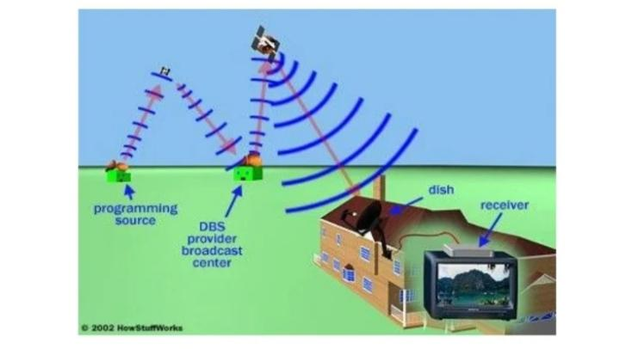

**CHAPTER 11**

**SATELLITE**

Geostationary satellites play an important role for DTH systems.

WHAT IS GEO STATIONARY SATELLITE Geostationary satellites are positioned at an exact height above the earth (about 36000 Km). At this height they rotate around the earth at the same speed as the earth rotates around its axis, so in effect remaining stationary above a point on the earth (normally directly overhead the equator). As they remain stationary they are ideal for use as communications satellites and also for remote imaging as they can repeatedly scan the same points on the earth beneath them. Polar Orbiting satellites by comparison have a much lower orbit, moving around the earth fairly rapidly, and scanning different areas of the earth at relatively infrequent periods. Motion of Geostationary Satellite around EARTH it is clear that geostationary satellite has circular orbit. In each orbit the time period remains same. Orbital plane is same as equator. Above 3 condition are necessary for a satellite to be a geo stationary satellite. Otherwise it will become geo synchronous satellite, which appears oscillating to an observer on the earth at fix location in sky. Focusing of a particular position on earth shows how geostationary satellite focuses apart of

earth.

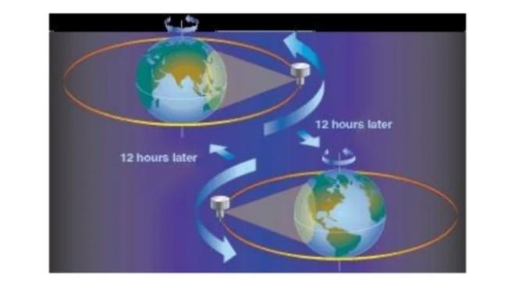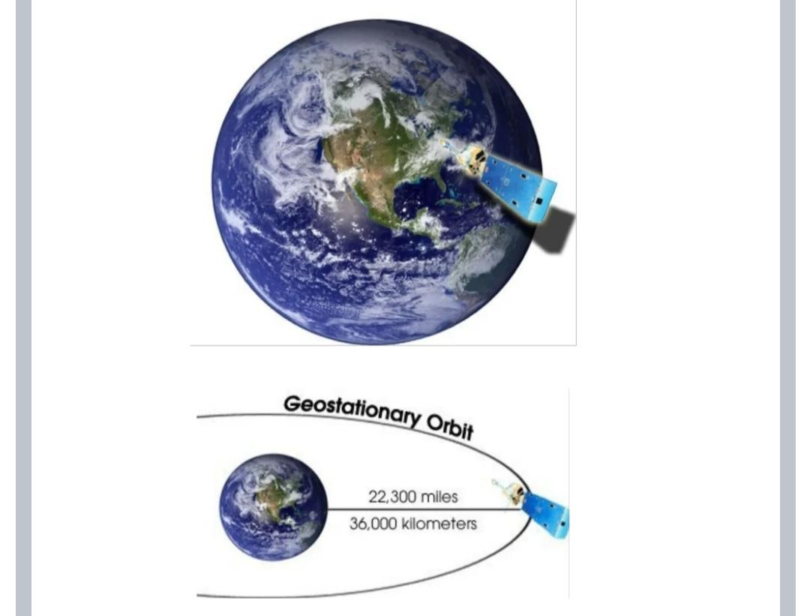

**CHAPTER 12**

**THE PROGRAMMING**

Satellite TV providers get programming from two major sources: national turnaround channels (such as HBO, ESPN and CNN)and various local channels (the NBC, CBS, ABC, PBS and Fox affiliates in a particular area). Most of the turnaround channels also provide programming for cable television, and the local channels typically broadcast theirprogramming over the airwaves. Turnaround channels usually have a distribution center that beams their programming to a geostationary satellite. The broadcast center uses large satellite dishes to pick up these analog and digital signals from several sources. Most local stations don't transmit their programming to satellites, so the provider has to get it another way. If the provider includes local programming in a particular area, it will have a small local

facility consisting of a few racks of communications equipment. The equipment receives local signals directly from the broadcaster through fiber-optic cable or an antenna and then transmits them to the central broadcast center. The broadcast center converts all of this programming into a high-quality, uncompressed digital stream. At this point, the stream contains a vast quantity of data -- about 270 megabits per second (Mbps) for each channel. In order to transmit the signal from there, the broadcast center has to compress it.

**CHAPTER 13**

**COMPRESSION**

The two major providers in the United States use the MPEG-2compressed video format the same format used to store movie son DVDs. With MPEG-2 compression, the provider can reduce the270- Mbps stream to about 5 or 10 Mbps (depending on the type of programming). This is the crucial step that has made DBS service a success. With digital compression, a typical satellite can transmit about 200 channels. Without digital compression, it can transmit about 30 channels. At the broadcast center, the high-quality digital stream of video goes through an MPEG-2 encoder, which converts the programming to MPEG-2 video of the correct size and format for the satellite receiver in your house. The MPEG encoder analyzes each frame and decides how to encode it. The encoder eliminates redundant or irrelevant data, and extrapolates information from other frames to reduce the overall size of the file. Each frame can be encoded in one of three ways: As an in reframe - An in traframe contains the complete image data for that frame. This method of encoding provides the least compression. As a predicted frame - A predicted frame contains just enough information to tell the satellite. Receiver how to display the frame based on the most recently displayed intra frame or predicted frame. This means that the frame contains only the data that relates to how the picture has changed from the previous frame. As a Dept.of Electronics Engineering

bidirectional frame - To display a bidirectional frame, the receiver must have the information from the surrounding intraframe or predicted frames. Using data from the closest surrounding frames, the receiver interpolates the position and color of each pixel. This process occasionally produces "artifacts" -- little glitches in the video image -- but for the most part, it creates a clear, vivid picture. The rate of compression depends on the nature of the programming. If the encoder is converting a newscast, it can use a lot more predicted frames because most of the scene stays the same from one frame to the next. In other sorts of programming, such as action movies and music videos, things change very quickly from one frame to the next, so the encoder has to create more in traframes. As a result, something like a newscast generally compresses to a much smaller size than something liken action movie.

**CHAPTER 14**

**14. ENCRYPTION AND TRANSMISSION**

After the video is compressed, the provider needs to encrypt it in order to keep people from accessing it for free. Encryption scrambles the digital data in such a way that it can only be decrypted (converted back into usable data) if the receiver has the correct decryption algorithm and security keys. What is Encryption is an electronic method of securing the video and audio of any TV program so that satellite, cable, and broadcast TV services can maintain control over the distribution of their signals. To receive encrypted or "scrambled" TV services, cable andSMATV system operators, hotel chains, private satellite networks, and home dish owners must possess a compatible decoder that can sense the presence of the encrypted TV signal and then automatically decode the pictures and sound Premium program services purchase the rights to movies from film production companies with the understanding that every individual will pay for the right to view them. Programmers also are very concerned about hotels, bars, and other commercial establishments that derive monetary benefit from signal piracy. Within a particular region, program producers may license more than one broadcast outlet for use of their programs. The program producer may require that broadcasters encrypt their signals whenever the broadcaster airs the producer's copyrighted material. This strictly limits reception of the programming to the

market for which each broadcaster is licensed. In some areas of the world, satellite broadcasters periodically must switch from agree-to-air to an encrypted transmission mode whenever required under their respective agreements with the program copyright owners .Each IRD contains a unique numerical address number that is installed at the factory. The satellite TV programmer's authorization center sends a coded conditional access message over the satellite that includes this unique address. This authorization message can turn on an individual IRD so that it can receive a particular service or group of services, or turn off an IRD in the event that the subscriber fails to pay the required monthly subscription fee. Moreover, the authorization center can use this addressable feature to selectively turn off and on large groups of decoders. Group IRD control is used to selectively "black out" TV events, such as a live championship boxing match, in certain countries for which the programmer does not own the distribution rights. Once the signal is compressed and encrypted, the broadcast center beams it directly to one of its satellites. The satellite picks up the signal with an onboard dish, amplifies the signal and use san other dish to beam the signal back to Earth, where viewers can pick it up. Bit Rate The amount of data information being transmitted in one second of time is called the bit rate, expressed in bits per second (b/s). A bit rate of one thousand bits per second is called a kilobit per second (kb/s); one million bits per second a megabit per second(Mb/s); and one billion bits per second a gigabit

per second(Gb/s).

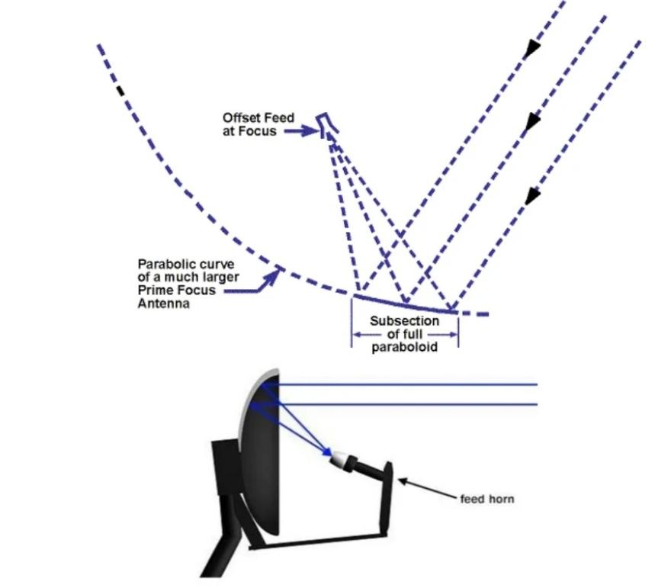

**CHAPTER 15**

**15.THE MOVING PICTURES EXPERT GROUP**

In 1988, the International Standards Organization (ISO) of the International Telecommunication Union established the Moving Pictures Experts Group (MPEG) to agree on an internationally recognized standard for the compressed representation of video, film, graphic, and text materials. The committee's goal was to develop a relatively simple, inexpensive, and flexible standard that put most of the complex functions at the transmitter rather than the receiver. Representatives from more than 50 corporations and governmental organizations worldwide took par tin the MPEG committee's deliberations. In 1991, the MPEG-1 standard was introduced to handle the compressed digital representation of no video sources of multimedia at bit rates of 1.5 Mb/s or less. However, MPEG-1 can be adapted for the transmission of video signals as long as the video material is first converted from the original interlaced mode to a progressively scanned format, which is subsequently transmitted at half the normal field rate. MPEG-1 commonly is encountered on IBM computers and other compatible platforms with the ability to display files using the *.mpg extension. A few TV programmers initially elected to use a modified form of MPEG-1 called MPEG-1.5 to transmit via satellite while the MPEG committee developed a standard for source materials using interlaced scanning. Although not an official standard, MPEG-1.5was adopted for use for a Dept.of Electronics Engineering wide variety of applications, including the transmission of educational TV services and niche-program channels. The MPEG committee selected its final criteria for a new standard in 1994 that resolves many of the problems with MPEG-1.

TheMPEG-2 standard features higher resolution, scalability, and the ability to process interlaced video source materials. MPEG-2 also features a transport stream that allows multiple video, audio, and data channels to be multiplexed at various bit rates into a single unified bit stream. There are so many similarities between MPEG-1 and MPEG-2, however, that MPEG-1 should be regarded as a subset of the MPEG-2 specification.

**CHAPTER 16**

**16. THE BROADCAST CENTER**

The broadcast center converts all of this programming into a high-quality, uncompressed digital stream. At this point, the stream contains a vast quantity of data 2 about 270 megabits per second (Mbps) for each channel. In order to transmit the signal from there, the broadcast center has to compress it. Otherwise, it would be too big for the satellite to handle. The providers use the MPEG-2 compressed video format 2 the same format used to store movies on DVDs. With MPEG-2 compression, the provider can reduce the 270-Mbps stream to about 3 or 10Mbps (depending on the type of programming). This is the crucial step that has made DTH service a success. With digital compression, a typical satellite can transmit about 200 channels. Without digital compression, it can transmit about 30 channels. At the broadcast center, the high-quality digital stream of video goes through an MPEG-2 encoder, which converts the programming toMPEG-2 video of the correct size and format for the satellitereceiver in your house.

**CHAPTER 17**

**17. RECEIVE TERMINALS**

The receive terminals are basically for the reception of the signals being beamed from the transmission station. The terminal consists of the following: receive type solid offset antenna LNB feed system Interface cables & Set top box The terminal can be placed outside the window of a high rise building, on the ground or a roof mount. The terminals can be used as per the contents being beam by the transmission stations.

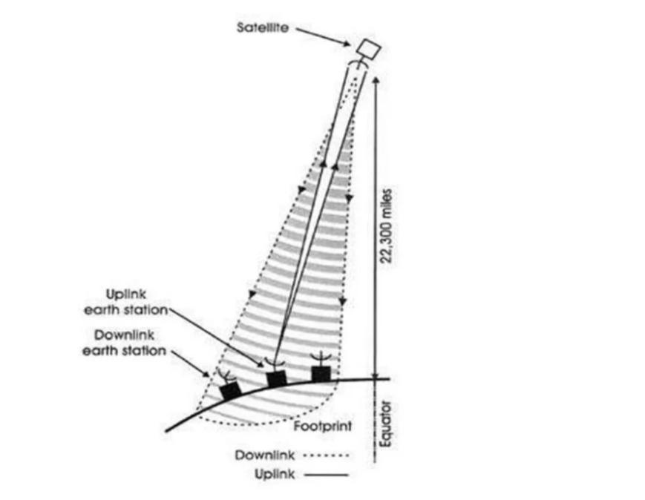

**CHAPTER 18**

**18. SATELLITE RECEIVING ANTENNAS**

Antenna size considerations: The selection of the appropriate antenna size helps in keep in the network up and healthy. It is decided based on the following:[] Satellite EIRP at the particular location. Rain attenuation at the location. Adequate Eb/No for reception of excellent picture quality. The satellite dish is a parabola of revolution, that is, a surface having the shape of a parabola rotated about its axis of symmetry. The resulting parabolic shares one key property of optical lenses: it is able to form an image of whatever object is placed in front of it. The largest optical and radio telescopes employ the parabolic reflector to gather and concentrate electromagnetic radiation. Any antenna surface irregularities or any departure from the precise parabolic shape will degrade the image resolution. As is more often the case, however, low resolution performance is the result of the installer's failure to grasp the importance of using good antenna assembly techniques. The parabolic curve has the property of reflecting all incident rays arriving along the antenna reflector's axis of symmetry to a common focus located to the front and centre.

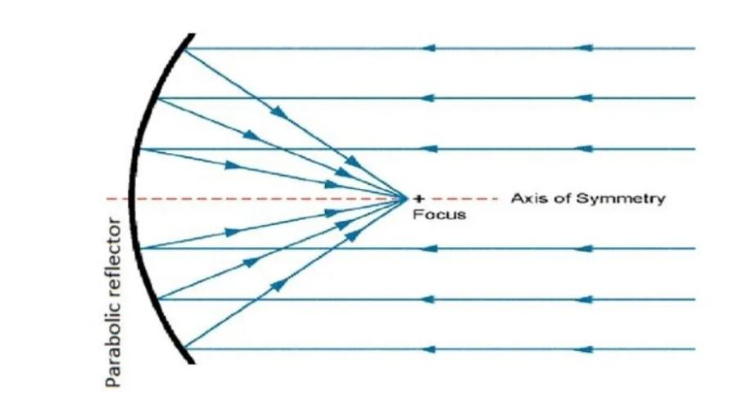

**CHAPTER 19**

**19. DTH APPLICATIONS**

a)To view pay & free-to-air TV channels of various DTH plat form on your home TV

b) Doordarshan free-to-air services providing 40 TV channels with no These channels comprises of DD channels and popular channels of news, sports, information, entertainment etc.c) One can scan the entire globe with a motorized dish using a CI set top box with CAM modules and watch TV channels of severalty platforms visible to the dish terminals') A number has started IP broadcast with return channel on PSTNline and this would be for education and other application.

**CHAPTER 20**

**DTH-BENEFITS**

Benefits of DTH extends to all sections of the society since DTH has a reachin all areas whether it is remote or urban, it provides equal benefits to everyone.Benefits of DTH are listed below: Cost effective communication, information and entertainment to all. Small size terminals can provide up to 4000 TV channels and2000 radio channels through a click of a button and thus brings world ds at least information, news, entertainment to your home . DTH services bypasses mediators and thus content provider comes with customer directly.[] DTH services are transparent providing digital quality video,audio, radio, and IP to all at equal prices and other benefits with reliability.

**CHAPTER 21**

**CONCLUSION**

DTH projects in India are jus DTH projects in India are just a beginning and we are taking the advantage of DTH revolution. Direct to home connects urban, rural and remote areas of the country and provides desire information communication, education and entertainment at the click of a button.1. Broadband noise will have negligible effect on GMRT Observations, as the minimum separation distance is 90meters with the assumption that there is no DTH system in 100meter circle from any of the GMRT antennas. Care must betaken for arm antennas.2. Narrow band noise can cause RFI, in spectral line observations below 400MHz, if located at about 2 km from a GMRT antenna. Further Work1. It is useful to be able to control LNB without set top box so as to understand the exact spectrum at LNB o/p. Effort is to be put to make the circuit on page 18 (or some other approach) work.2. Effect of Narrow band noise on GMRT must be studied in detail.

**CHAPTER 22**

**REFERENCES**

1. EN 50221: Common Interface Specifications for conditional access and other Digital video broadcasting decoderapplications.2.IS 15377-2003: Digital Set Top Box for Direct to Home services

2. Effect of corDECT systems on GMRT (Internal Technical Report)4. THE DIGITAL SATELLITE TV HANDBOOK MARK E. LONG

3. [www.mindstien.net](http://www.mindstien.net)

4. [www.scribd.com](http://www.scribd.com)

5. [www.googleearth.com](http://www.googleearth.com)

6. [www.howstuffwork.com](http://www.howstuffwork.com)